**Name: Adedapo Abiodun Joseph**

**Matric: 2019235020021**

**Course: Database Design (COM312)**

**ENROLLMENT TABLE**

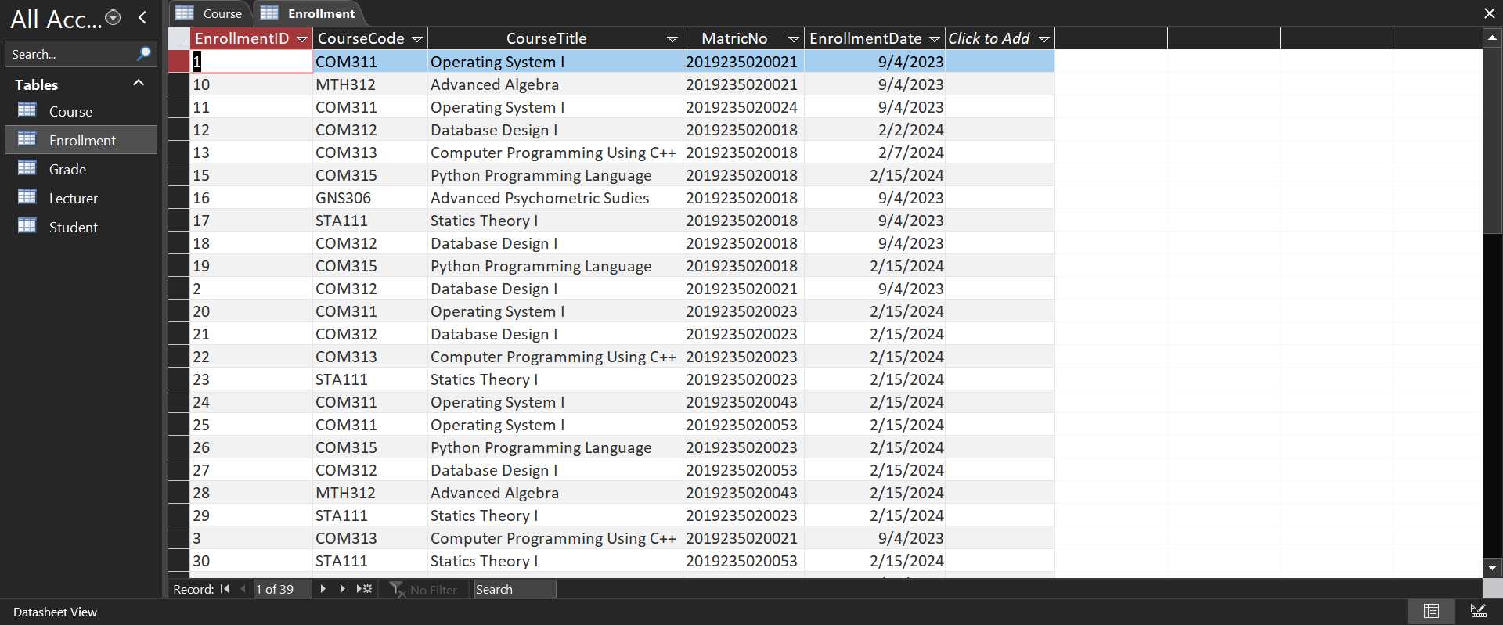

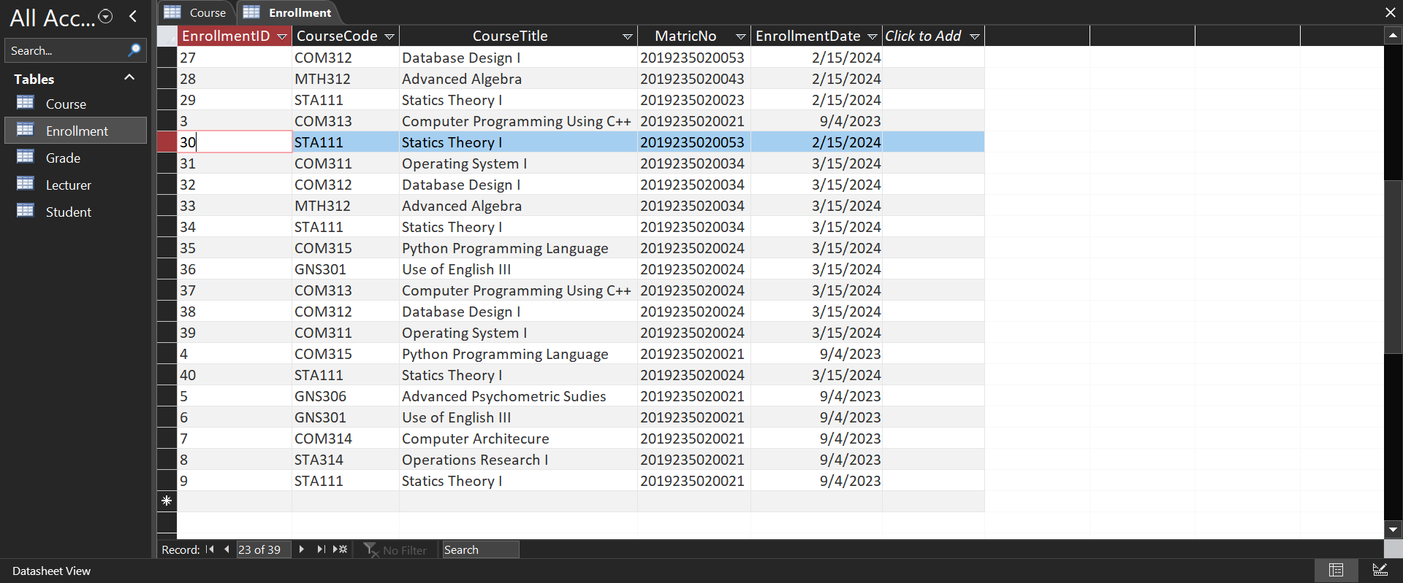

Datasheet View

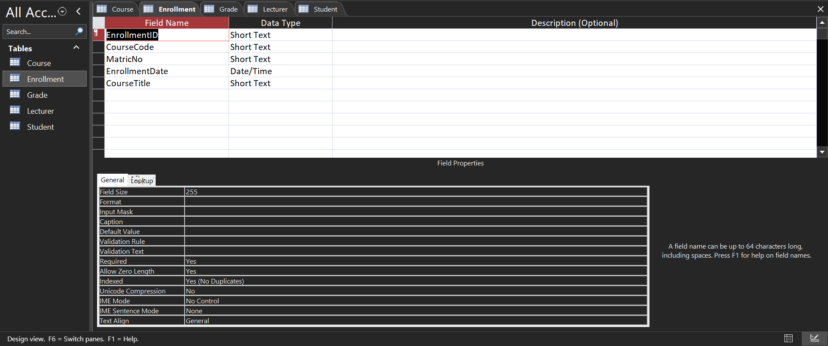

Design View

**STUDENT TABLE**

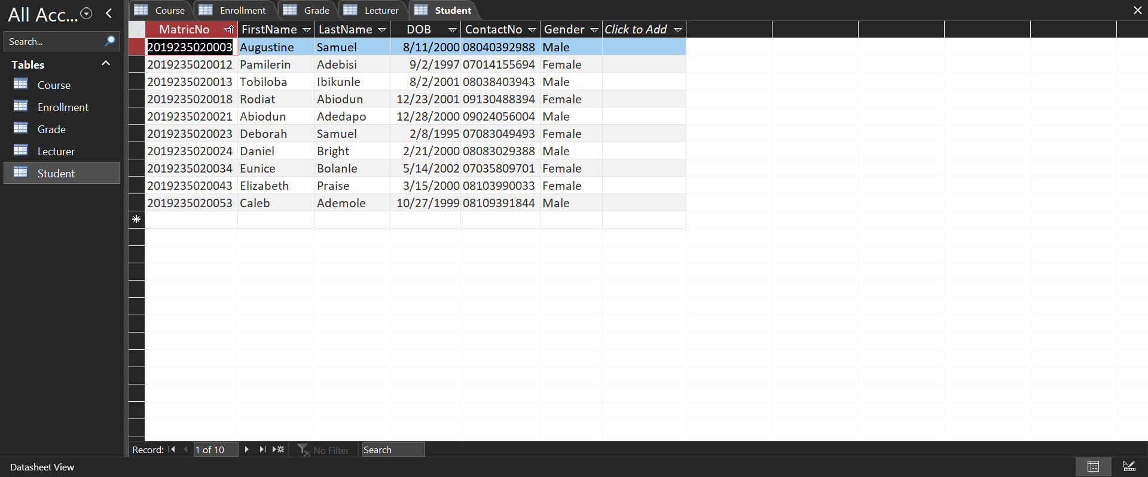

Datasheet view

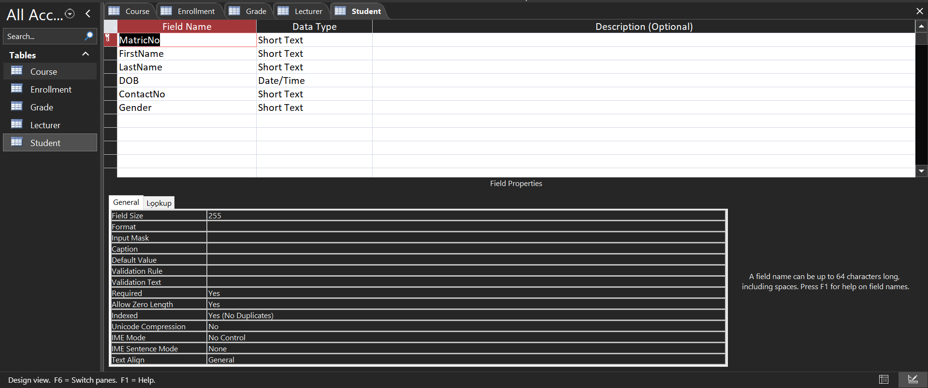

Design View

**GRADE TABLE**

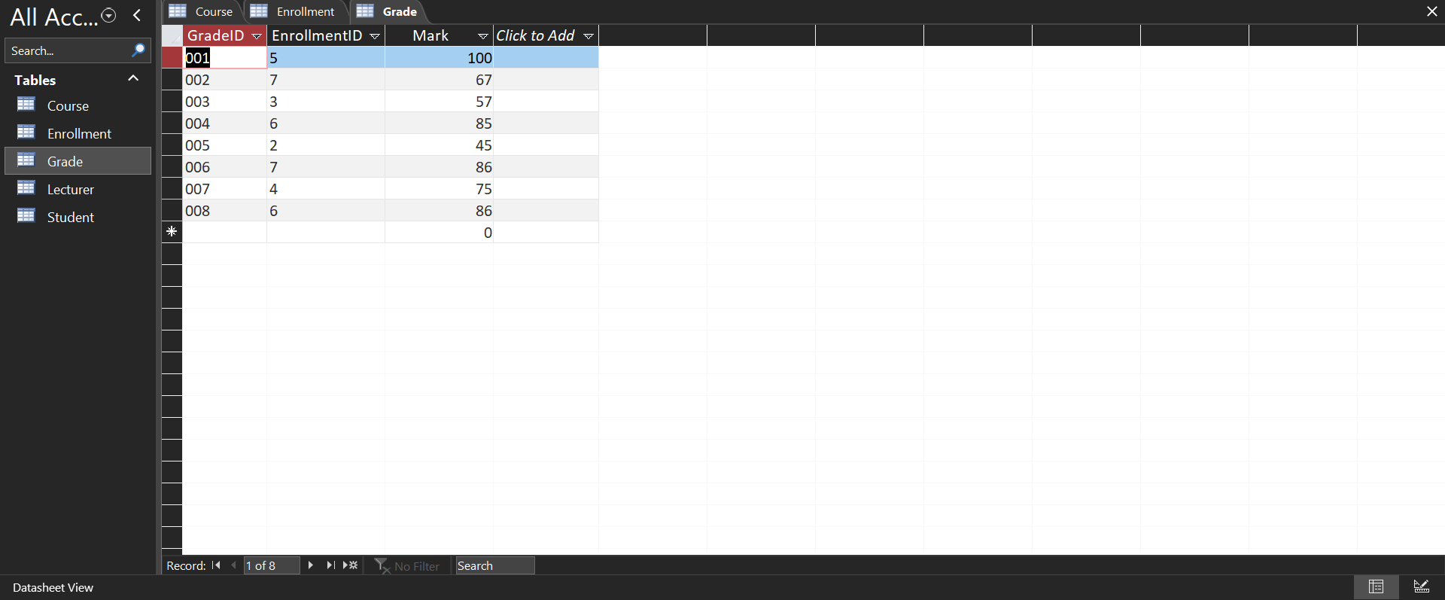

Datasheet View

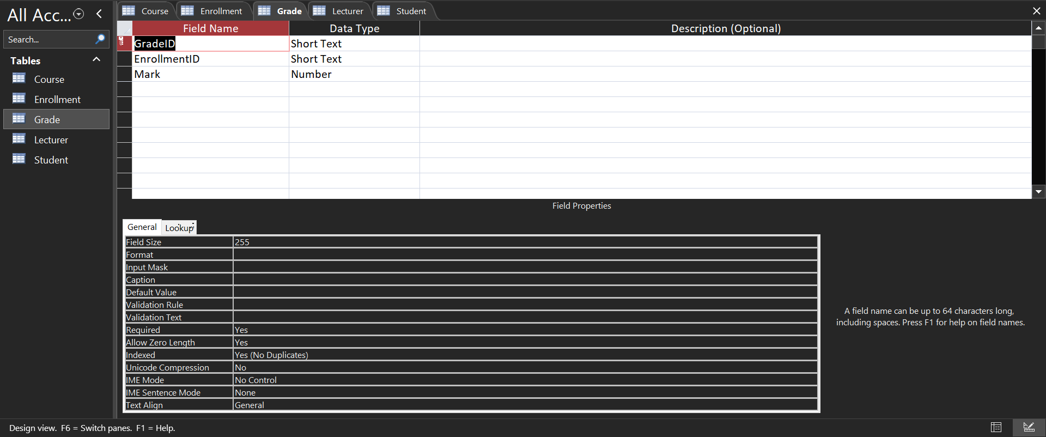

Design View

**COURSE TABLE**

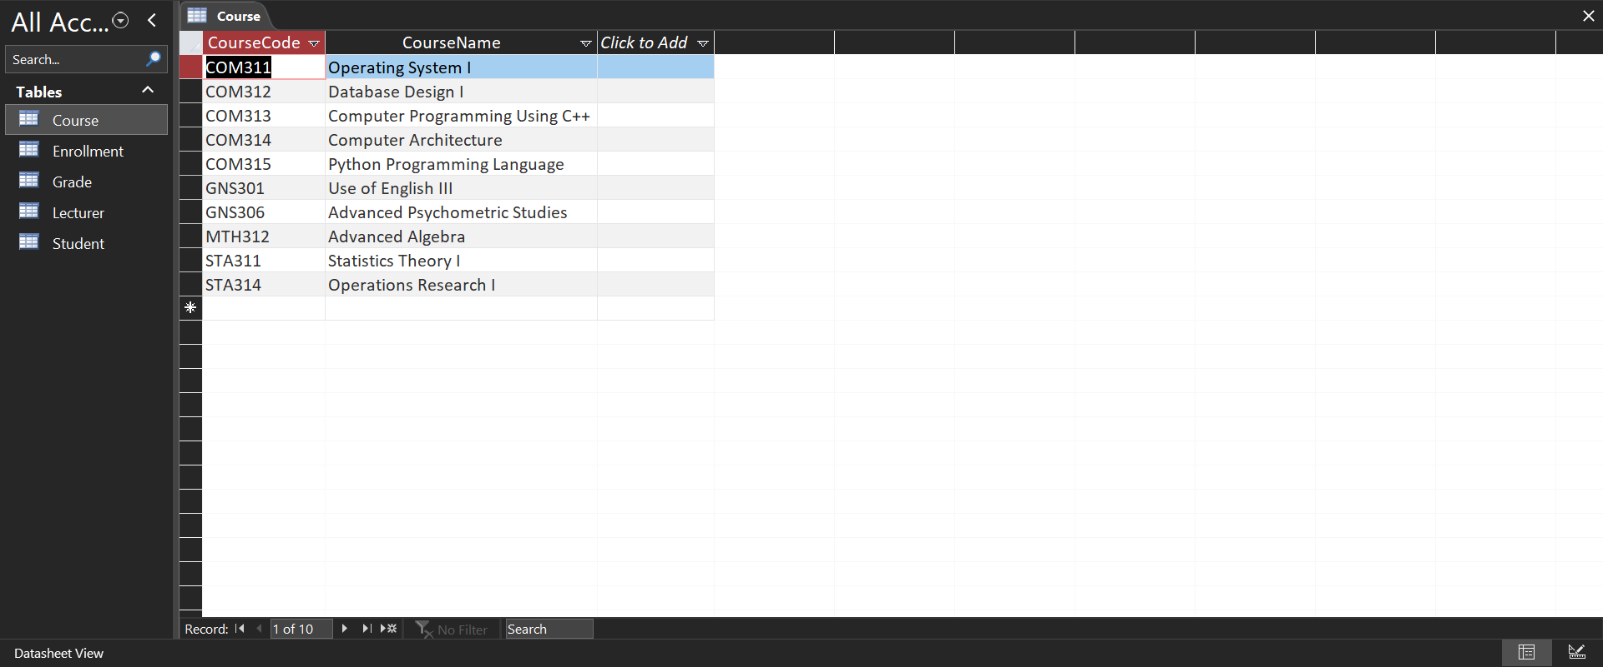

Datasheet View

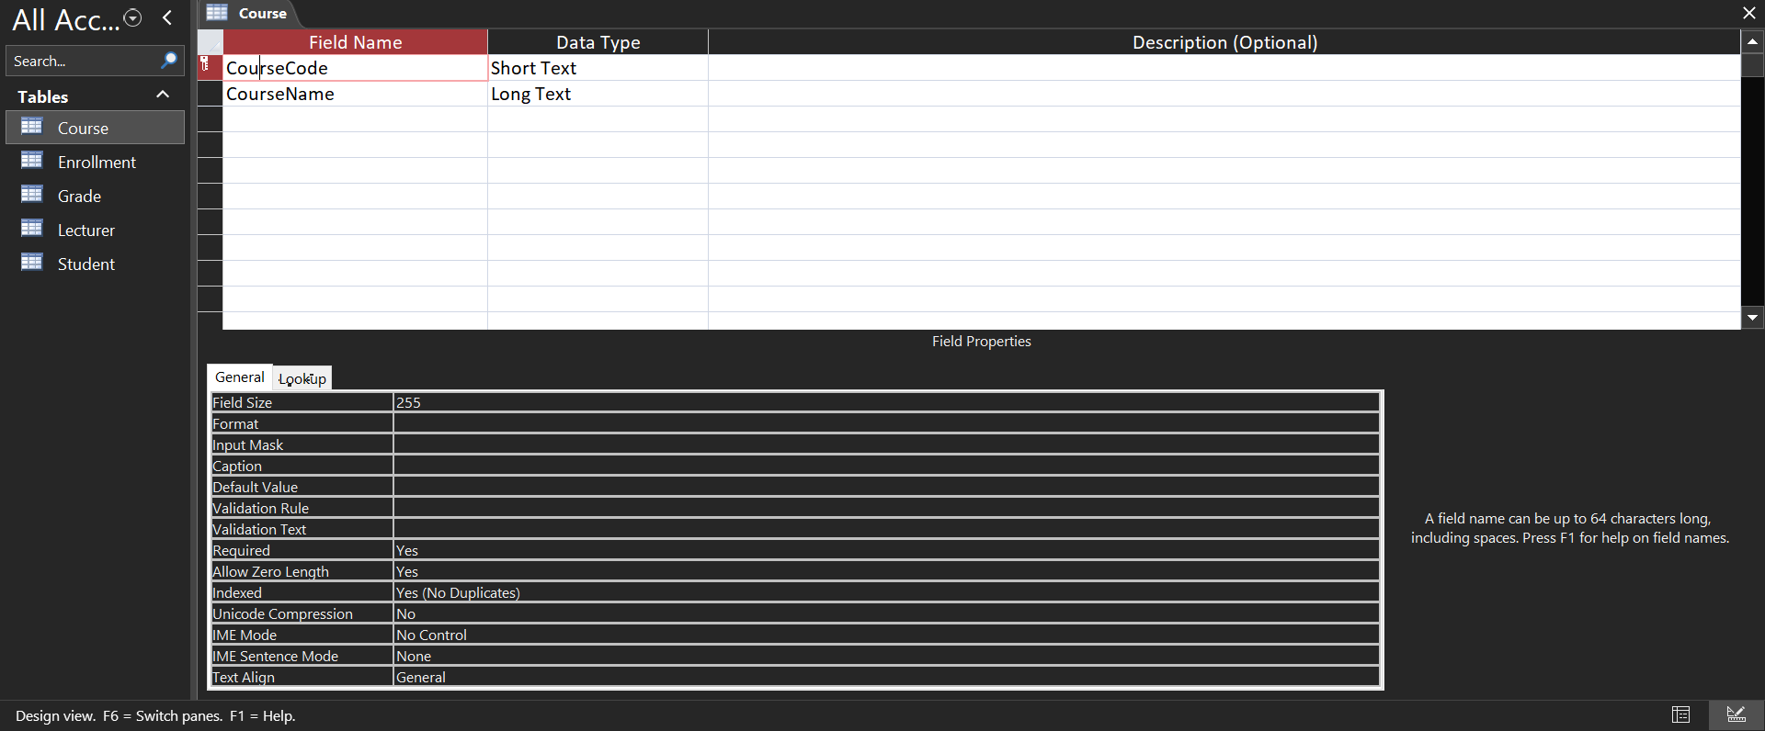

Design View

**LECTURER TABLE**

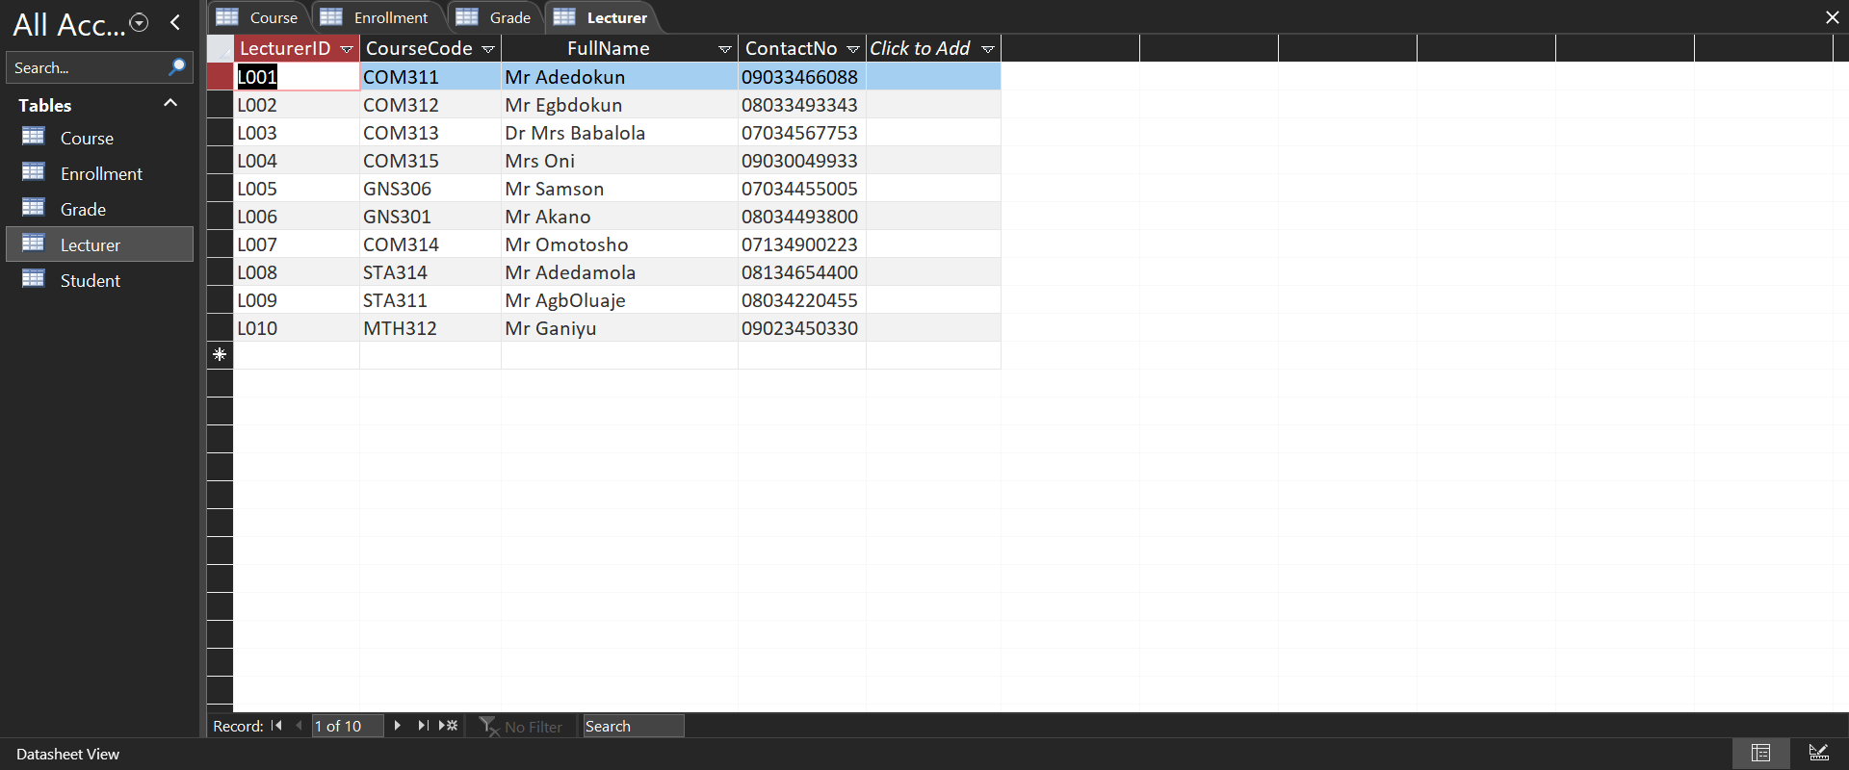

Datasheet View

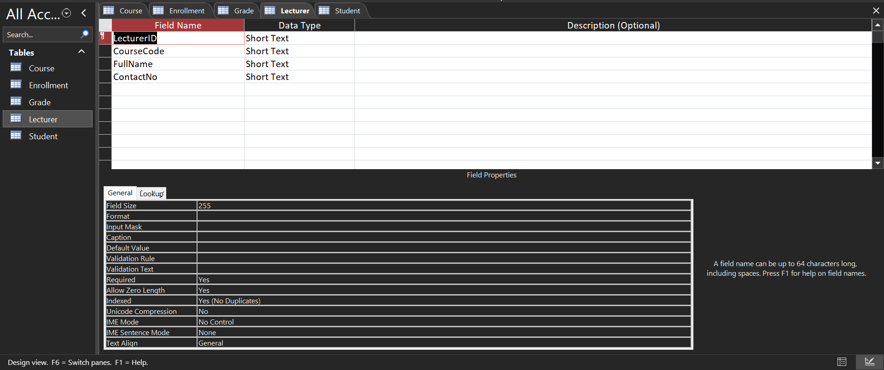

Design View